These methods could enable a clear, NON-patronising time limit to be placed on player turn if needed. (assuming vertical oriented game scene, no problem RE passing device between players).

**Sprites to denote optimal time to pull through rope being slack/taught**

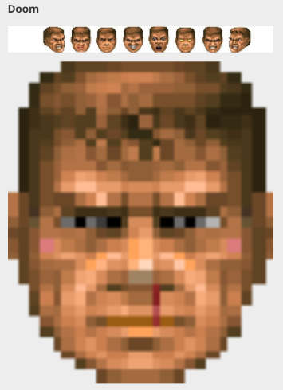  
http://www.gamesradar.com/the-10-most-creative-life-bars/ [2013]



No tension

Full tension

**Colour background change**

<http://codezag.com/wp-content/uploads/2015/03/change-background-color-javascript.gif>

Maintain coloured perimeter in current version to indicate current player turn.

Remainder of background gradient change/pulse with colour.

Closer to colour (e.g. green) better pull.

Closer to colour (e.g. red) worse pull.

Could be made to fit a rhythm, rather than set gradient change/pulse change.

**Additional output**

**UI images**

Sprites with theme relevant alternative to ‘Heave-ho’ could pop in/out at optimal time.

e.g. ‘heave’ sprite could indicate time to tap for strongest pull, ‘-ho’ could appear on the offbeat.

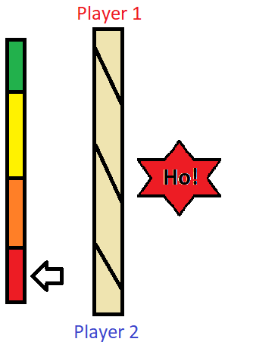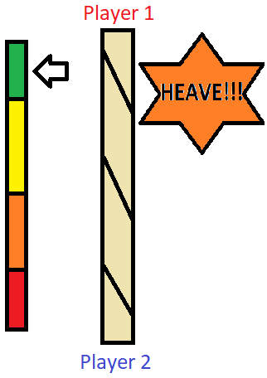

**Device sound and/or vibration**

Haptic feedback could pulse to indicate optimal time, becoming stronger/more frequent.

Sound could be played in a similar manner to denote the strength of the players actions.

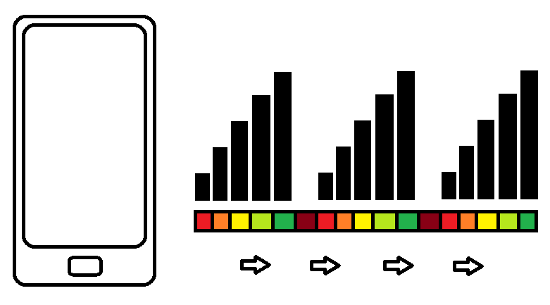

**The use of vibration/sound alongside the game screen would allow non-linear patterns to be conveyed to the player more effectively than on screen visuals.**

**Use of the game scene ‘environment’**

One result of the groups sprint 2 game jam styled work session was the idea to adapt the game design, making the background a liquid. Ripple animations could then be used in a similar way to the above methods to describe to the result of a tap input to the player.

